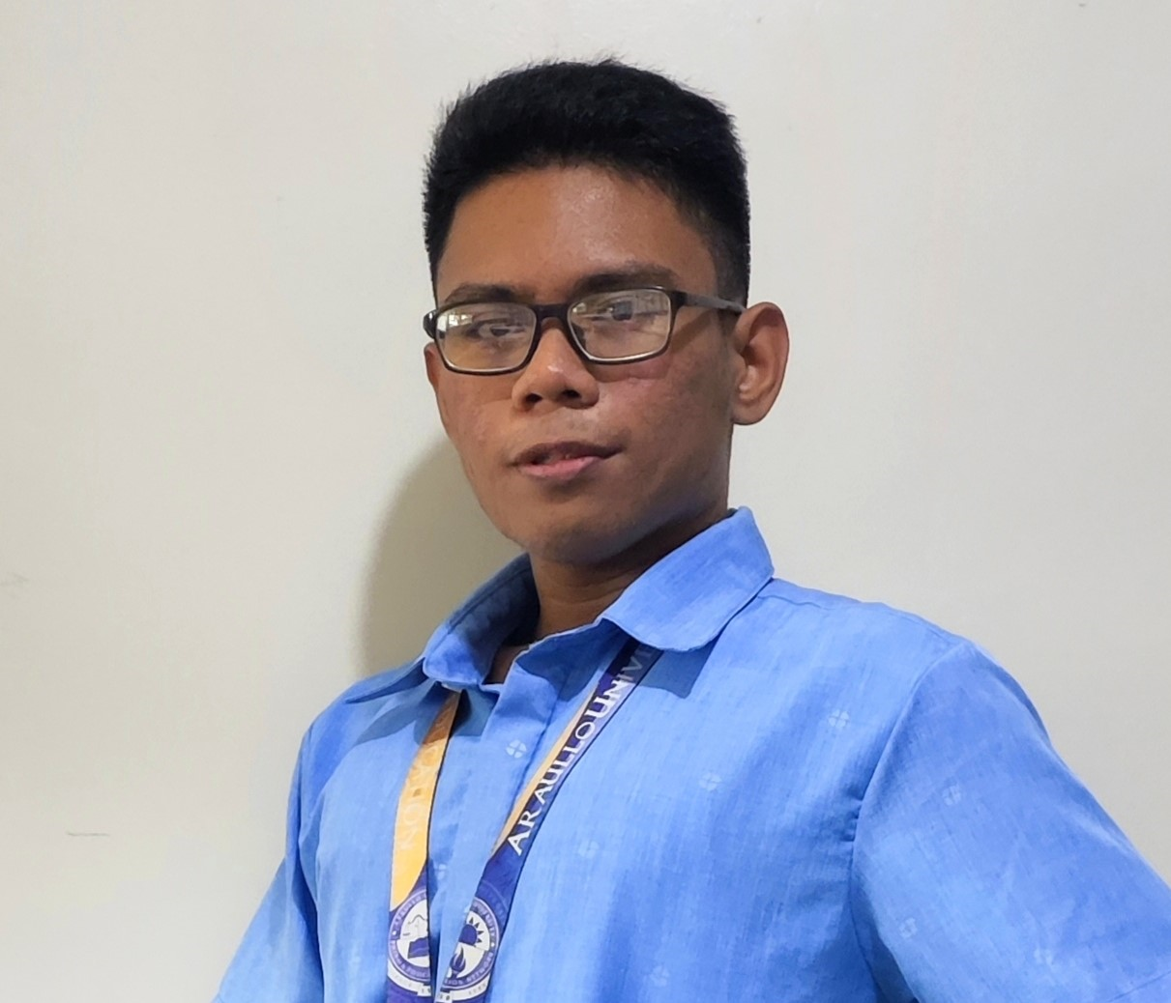

|  |  |  |  |  |
| --- | --- | --- | --- | --- |
|  | | |  | Vincent Santaygillo |
| Who am I?   My name is Vincent, my friends call me V. I’m a hobbyist, I love computers, and just technology in general. I like to build PCs, Servers, Networks, Smartphones etc. I also have experience with Web development, Cyber Security and Video Editing.EducationPHINMA - Araullo University Bachelore of Science in Information Technology **•** 2020 – Present PHINMA - Araullo University Senior High School**•** 2018 – 2020 **•** With Honors PHINMA - Araullo University Junior High School **•** 2014 – 2018 Roxy Lefforge Foundation Colleges Elementary **•** 2008 – 2014 Skills  * Proficient with Computer Hardware * Networking * Web Development * Cyber Security * Project Management * Communication Skills  Programming Languages and Tools |
|  | **Profile**  Date of Birth: December 10, 2001 Age: 21 Gender: Male Marital Status: Single Nationality: Filipino  **Contact** | |
|  | Address:  Purok ImeldaCabu, Cabanatuan City, Nueva Ecija  Phone:  09165271189  Email:  Entengice99@gmail.com | |
|  |  |  |
|  |  | |  |